Nonlinear Optimization Project Report

卢博 11849159

***Abstract-*The frequent occurrence of road traffic accidents has affected people's travel efficiency and travel safety. Traffic sign detection has become one of the key research objects in intelligent transportation system. This paper studies the detection of road traffic signs based on video images. First, collected image will be image preprocessing with image reduction, brightness adjustment, filtering. Secondly, the method of feature extraction of traffic signs is studied to train traffic sign samples. According to the characteristics of many kinds of traffic signs, select linear kernel function and combine one to one SVM classifier to classify traffic signs. Finally, the traffic signs are identified based on MATLAB software. The results show that the traffic signs can be accurately identified.**

***Keywords- Road traffic sign; Detection; Feature extraction; SVM***

1. INTRODUCTION

My project is Traffic Sign Detection. This project is important in machine learning’s area. Especially in automatic drive technology. The rapid development of the global economy makes the number of traffic vehicles into the period of rapid growth and the car has become an important way to public travel. The traffic sign is a significant part for driving security, it provides many key information of road for drivers. In order to build a self-driving system, image detection must be considered heavily, it is the fundamental system for further artificial intelligence decision make. We plan to build an effective model to detect the traffic signs. Review literature: The improvement of intelligent transportation system requires accurate traffic sign detection and identification. The domestic and foreign research methods of traffic signs is the traffic sign segmentation, detection of traffic signs and the identification results provide driving and participants, the unmanned vehicle is transferred to the control system identification results[1][2]. Based on the above, this paper adopts the image processing technology to process the collected traffic sign images, then classifies and identifies the traffic signs through support vector machine (SVM). The results of the final experiment show that the traffic signs can be accurately identified.

1. Image preprocessing

Traffic signs are difficult to be detected easily in complex environment. It is necessary to adjust the image brightness and eliminate noise by preprocessing. The pretreatment process is divided into image reduction, brightness adjustment and image filtering[2].

A. Image reduction

Image reduction is a sampling process. The drop sampling will greatly improve the efficiency of traffic sign detection. In this paper, the real road image is operated by bilinear interpolation algorithm, the original size is 1023×728. The size is 64*64 after sampling.

B. Image brightness adjustment

Histogram equalization is a common image brightness adjustment technique in image processing. Algorithm idea: Count the number of times of each gray level in the histogram, then normalize, finally calculate the new gray value.

C. Image filtering

Median filter is widely used in two-dimensional image processing to eliminate the interference of bipolar pulse or unipolar pulse. The details of the image and other information can be well preserved[3].

# Algorithm based on hog feature extraction

Here I use Histogram of Oriented Gradient(HOG)[4] and Support Vector Machine(SVM) methods to get the model.

HOG: Divide image into small connected areas, which we call cell. A gradient or edge direction histogram of each pixel in the cell is then acquired. These histograms can be combined to form a feature descriptor. The examples are show in Figure 1(a), (b) and (c). In Figure 1(a), the image is divided into some cells, each cell is 8pixels × 8pixels.

图片包含 障子

自动生成的说明

Figure 1(a) Each cell is 8pixels × 8pixels

Then calculate the gradient of this matrix as show in Figure 1(b), we get the gradient or edge direction histogram of each pixel in the cell, these histograms can be combined to form a feature descriptor.

There are 9 features that from 0 to 2π for each cell. The height of bin is controlled by the value of gradient. For example, if the direction of gradient is at a 45o angle to the x axis, then combine the value of this gradient into the interval from $\frac{2}{9}π$ to $\frac{4}{9}π$. The histogram of one cell is shown in Figure 1(c).

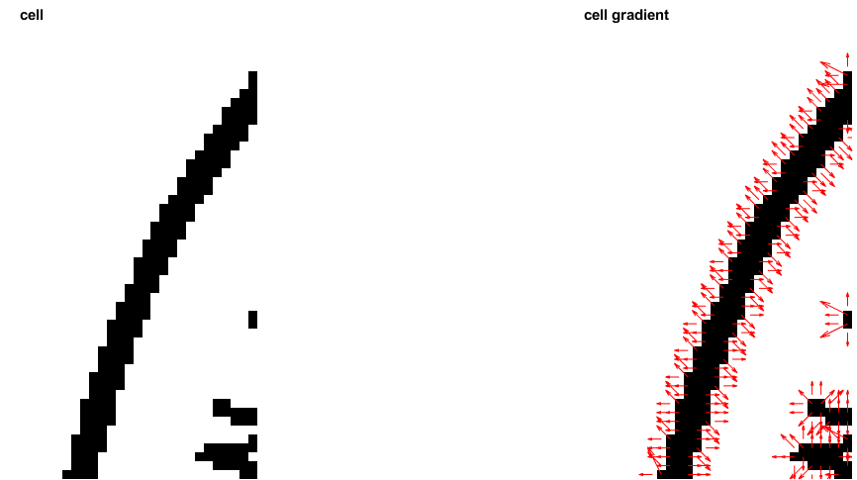

Figure 1(b) Gradient of Cell

图片包含 屏幕截图

自动生成的说明

Figure 1(c) Features of 1 Cell

In Figure 1(d), let 4 cells group into a block, combine 4 cells’ feature to form the feature of this block. And combine the features of several block, we get the feature of this image. Donate this image into 1 or -1, we will get a vector include the image’s feature and it’s value.

图片包含 障子

自动生成的说明

Figure 1(d) Block contains 4 cells

SVM[5]: as show in Figure 2, these different vectors donate different points. The support vector will be found if get the maximum margin. And we get a model of different points.

To maximize the margin:

*min $\frac{1}{2}||$* 𝑤 ${||}^{2}$

*s.t $y_{i}$* ($w^{T}$*× $x_{i}$ +b*) *≥* 1

Then convert to:

$\max_{α}⁡$ $∑α_{i}-\frac{1}{2}∑∑α_{i}α_{j}y_{i}y_{j}x_{i}^{T}x_{j}$

*s.t $∑α_{i}y_{i}=0$, $α_{i}\text{ ≥ 0}$*

So, we need to get the $α_{i}$, then 𝑤 will be solved.

图片包含 文字, 地图

自动生成的说明

Figure 2 Support Vector Mathine

Combine HOG and SVM

HOG: Extract features, each image: {$x_{1},x_{2}, …,x_{i}$}, donate the image to be 1 or -1. For samples, we get a matrix:

$$\left[\begin{aligned}x_{11},x_{12}, …,x_{1l}, 1 \\ x_{21},x_{22}, …,x_{2l}, -1 \\ … \\ x_{n1},x_{n2}, …,x_{nl}, -1 or 1\end{aligned}\right]$$

SVM: Classifier: Put the multidimensional matrix into SVM, we get the *support vector, alpha* and *rho.* Classifier = [*alpha* support vector, rho*]

1. Detection of traffic signs

Traffic sign detection based on Support Vector Machines. The biggest advantage of the support vector machine is the introduction of kernel functions, which makes the linear indivisible problem transformed into a linear separable problem in high dimensional space [6]. HOG feature is used to extract the feature of traffic signs. Linear kernel function is used to classify the features because of the high dimension of feature. For the 2 classes problem of support vector machines (SVM), this paper adopts the one to one method with short training time and high training efficiency. The sample training is divided into four steps:

Step 1: Image preprocessing and HOG feature extraction, feature vectors are used to identify the sample library.

Step 2: Since traffic signs have more training samples and higher feature dimension, linear kernel function is adopted to ensure identification.

Step 3: The sample set is divided into 2 part. One part is used as training sets to obtain training parameters. Another part is used to get the test error data. The n error is averaged to obtain the estimated generalization error of the model, that is, the optimal model. Retraining all samples to obtain the required parameter model.

Step 4: Classification is performed using the Predict_svm function. Through the data model to predict the input data classification. We only need to send the flag image HOG feature data of the test identification into our designed one to one support vector machine classifier, then we can complete the traffic sign judgment.

1. Experiment and analysis

*A. Sample database*

There is no uniform sample database of road traffic signs in China at present. Therefore, the traffic signs are rotated at a certain angle to simulate the effect of the actual shooting process. Then sort it into a database. This paper chooses one traffic sign -- speed limit at 70 sign as the positive samples and there are 1980 images in these samples. In addition, the negative samples is 1980 images that not include traffic signs. Mix up the positive and negative samples into one sample and randomly split it into 2 sets: training set and testing set. Each image in the training and testing set is reduced to 64 * 64 pixels and has 9×4×7×7=1764 features. Some of the training samples are shown in Figure 3(a) and Figure 3(b).

图片包含 照片

自动生成的说明

Figure 3(a) Positive training images

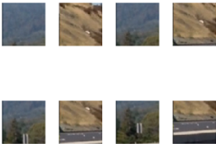

Figure 3(b) Negative training images

*B. Experimental results*

The results of testing set are show in Figure 4.

图片包含 屏幕截图

自动生成的说明

Figure 4 Results of testing set

Randomly download 2 images, Figure 5(a) and (b) are the results by using the SVM implement in this paper, Figure 5(c) and (d) are the results by using the SVM in the MATLAB lib package.

图片包含 草, 标牌, 天空, 户外

自动生成的说明图片包含 树, 户外, 天空, 标牌

自动生成的说明

Figure 5(a) and 5(b) Results by using SVM implement in this paper

图片包含 草, 标牌, 天空, 户外

自动生成的说明图片包含 树, 户外, 标牌, 天空

自动生成的说明

Figure 5(c) and 5(d) Results by using SVM in MATLAB lib package

*C. Analysis*

As show in Figure 4, all images in the testing set are detected correctly. That means the positive images are marked as +1, and negative images are marked as -1.

For a random image, make a sliding window in the image and detect the sign. The detections of 2 methods are also very close as shown in Figure 5(a)(b)(c)(d).

But there are still some problems in the project:

1. The sliding window’s size

In different images such as 1023×728 or 427×640, the signs have different pixel sizes. That how to design the sliding window’s size is still a big problem.

2. Wrong detection.

Both SVM implement in this paper and SVM in MATLAB lib package have wrong detection.

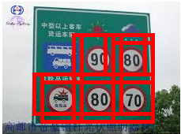

Figure 6(a) SVM implement in this paper

图片包含 文字

自动生成的说明

Figure 6(b) SVM in MATLAB lib package

1. Conclusions

Traffic signs is identified by using MATLAB based on video image processing technology. A set of traffic sign samples is set up and a SVM classifier based on a one-to-one classification algorithm is designed. The appropriate size partitioning HOG area block is selected. The experiment is carried out to verify the effectiveness of the proposed method. The experimental results show that SVM classifier based on one-to-one classification algorithm can realize the identification of traffic signs more accurately. We believe that with implementation neural networks and machine learning will significantly improve the accuracy.

1. Gantt Chart



References

[1] Zhao, J. D. , Z. M. Bai , and H. B. Chen . "Research on Road Traffic Sign Recognition Based on Video Image." International Conference on Intelligent Computation Technology & Automation 2017.

[2] Garrido, Miguel Ángel G, M. Á. Sotelo, and E. Martíngorostiza. "Traffic sign detection in static images using Matlab." Emerging Technologies & Factory Automation, Etfa 03 IEEE Conference 2003.

[3] Miura J, Kanda T, Shirai Y. “An active vision system for real-time traffic sign recognition”. Intelligent Transportation Systems, 2000. Proceedings. IEEE, 2002, pp.52-57.

[4] Dalal N, Triggs B. “Histograms of Oriented Gradients for Human Detection”. Computer Vision and Pattern Recognition, 2005. CVPR 2005. IEEE Computer Society Conference on. IEEE, 2005, pp.886-893.

[5] 凸优化对偶问题 http://www.hanlongfei.com/convex/2015/11/05/duality/

[6] Zhang Y, Li B, Lu H, et al. “Sample-Specific SVM Learning for Person Re-identification”. IEEE Conference on Computer Vision and Pattern Recognition. IEEE, 2016, pp.1278-1287.